## **Transmembrane voltage, Vm**

### **Time**

**Given**:

* resting voltage, Vr = - 60mV
* AP with peak voltage 30mV (90mV amplitude)
* upstroke center time, 4ms
* downstroke center time, 8ms
* rising time (10% to 90%), 1ms
* falling time (90% to 10%, 3ms

**Formula**:

**Answer**: Vm (t) = -60 + 45 * tanh(2.2(t - 4)) - 45 * tanh(0.73(t - 8))

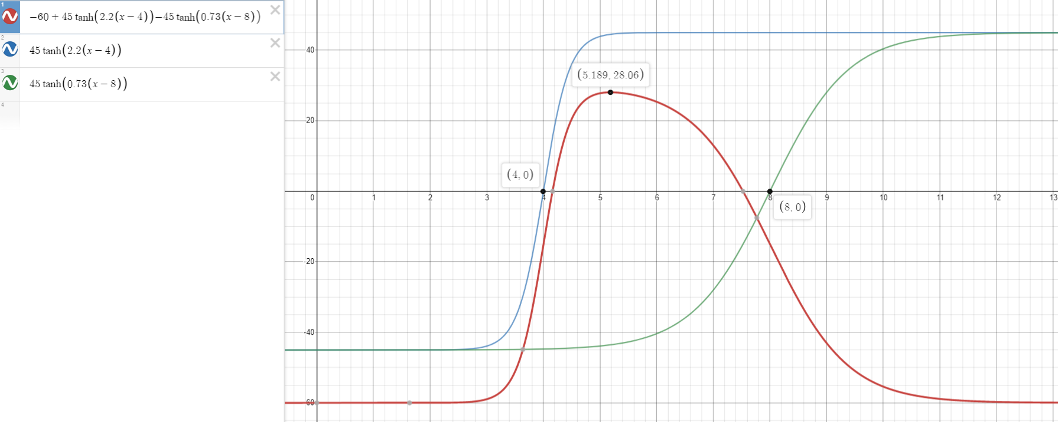

### **Space**

**Given**:

* Vm(t)
* Speed of propagation, u = 2 m/sec
* X0 = 7 (we want x=0 to be at 10% of upstroke at t=0)
* T0 = 0
* Right-moving wave

**Formula**: 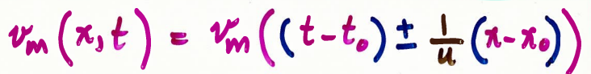

**Answer**: Vm (x,t) = Vm (t - (x - 3.5) / 2)

Vm (x,t) = -60 + 45 tanh( 2.2(t - 4 - (x - 7) / 2)) - 45 tanh(0.73(t - 8 - (x - 7) / 2))



## **Transmembrane current, im**

**Given**:

* a = 100 μm
* σi = 0.02 S/cm
* Assuming σe is infinite

**Calculations**: Let t = 1.7, such that the Vm(x = 0) is at its peak amplitude

Vm (x) = -60 + 45 * tanh(2.2(-2.3 - (x - 7) / 2)) - 45 * tanh(0.73(-6.3 - (x - 7) / 2))

dVm/dt = -49.5 * sech2(2.2(-2.3 - (x - 7) / 2)) + 16.425 * sech2(0.73(-6.3 - (x - 7) / 2))

d2Vm/dx2 = -108.9sech2(2.2(-2.3 - (x - 7) / 2)) * tanh(2.2(-2.3 - (x - 7) / 2)) + 11.99 * sech2(0.73(-6.3 - (x - 7) / 2)) * tanh(0.73(-6.3 - (x - 7) / 2))

im (x)= π * a2 * σi * d2Vm/dx2

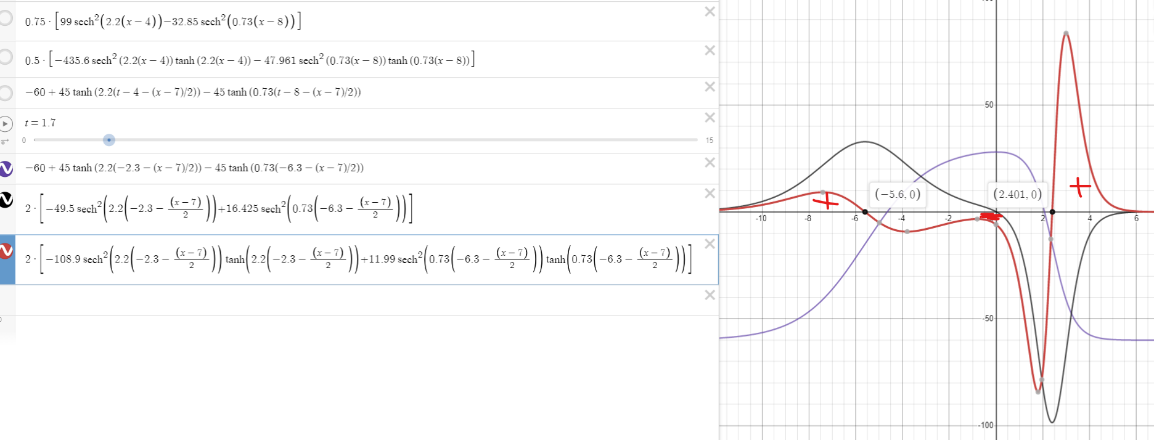

## **Lumped monopoles**

**Given**:

* im (x) function

**Formulae**: 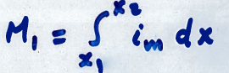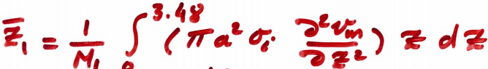

**Calculations:** let wire run from -20 < x < 20

Let π * a2 * σi = b = 6.2832 * 10-8 [S*m]

M1 = 16.423 * b (mA) = 1.0319 nA (at x = -8.338)

M2 = -65.735 * b = -4.1303 nA (at x = 0.397)

M3 = 49.310 * b = 3.0982 nA (at x = 3.307)

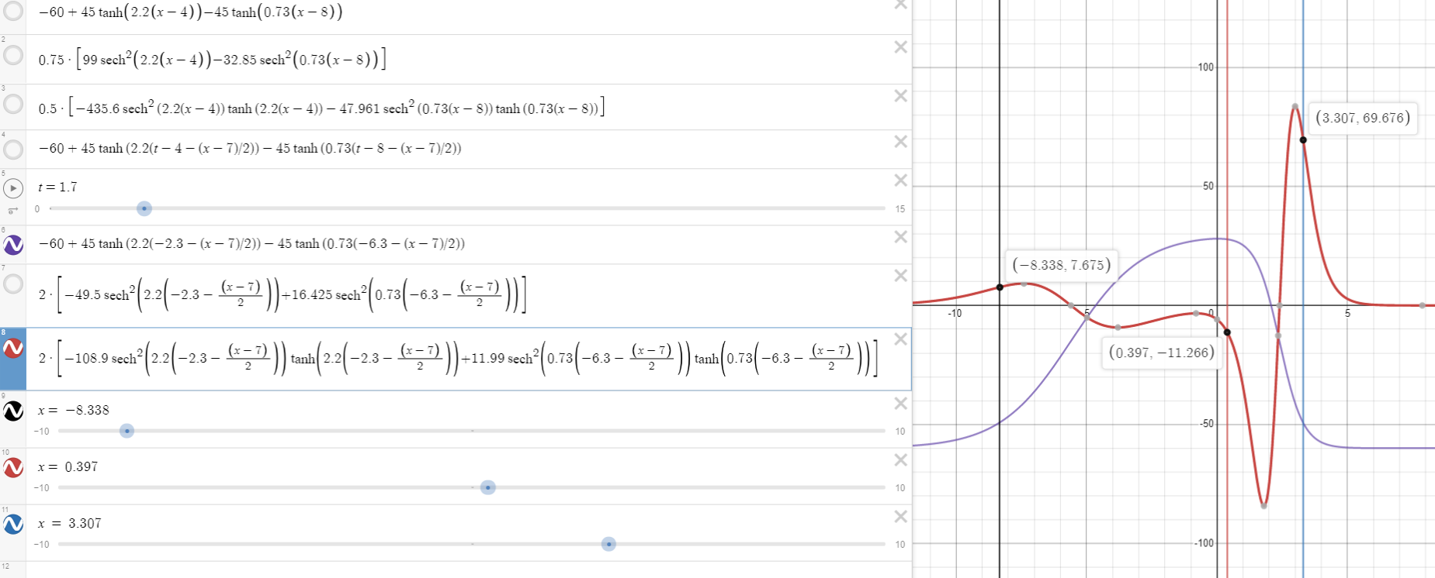

## **Extracellular potentials, Φe**

## **Space**

**Given**: Monopole magnitudes and locations

**Formula**: 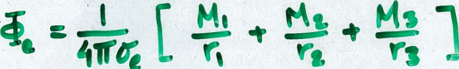

**Calculations:**Lets examine the potential along a line parallel to the x-axis, at a height of y = 2, ie. (x, 2, 0)Let 1 / (4 * π * σe) = c = 7.958 * 10-3 [Ω * m]

Φe (x) = c * 10-9 (1.0319/sqrt((x + 8.338)2 + 1) - 4.1303 / sqrt((x - 0.397)2 + 1) + 3.0982 / sqrt((x - 3.307)2+ 1))

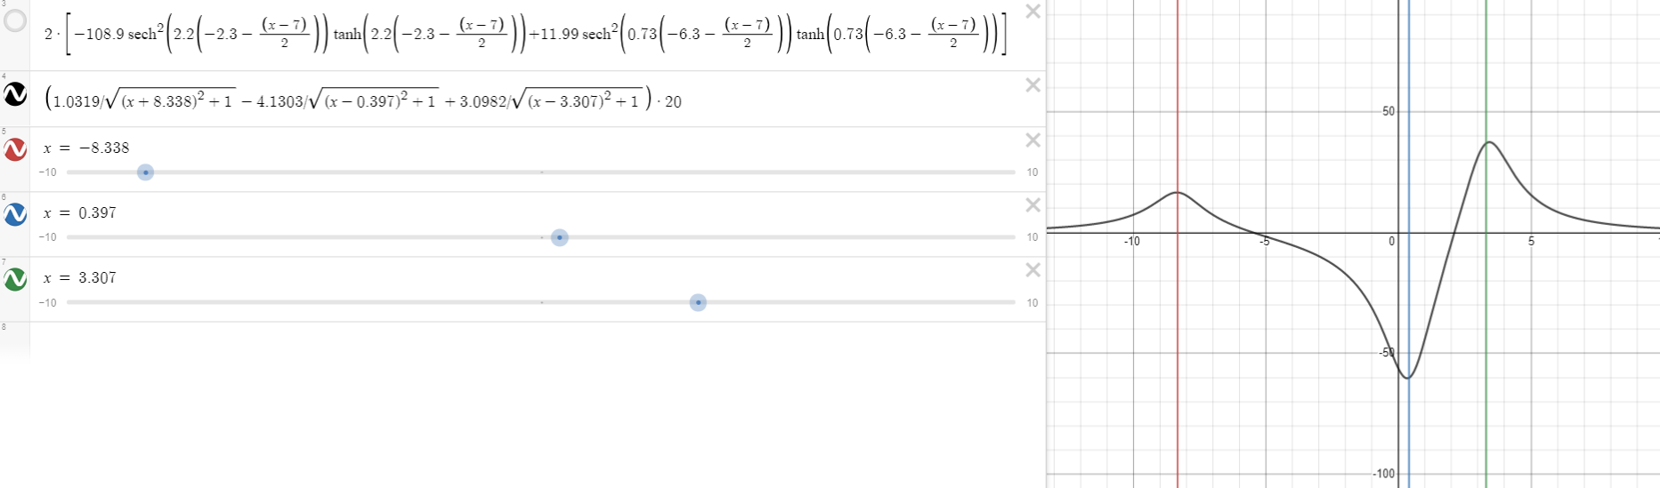

The minimum is at x = 0.328, where we have C * 10-9 * -60.325 A/m= **-0.4801 nV**

## 

## 

## 

## 

## **Time**

**Given**:

* Extracellular potential in space
* Speed of propagation, u = 2 m/sec (Right-moving wave)
* Let to = 1.7 (such that the Vm  is at 10% of its rising phase at x = 0)
* Let xo = 0, x = 0.328 (at the minimum from before)

**Formula**: 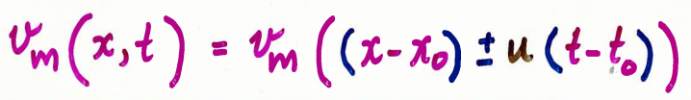

**Answer:** Φe (t) = c * 10-9 * (1.0319 / sqrt(((0.328 - 2(t - 1.7)) + 8.338)2 + 1) - 4.1303 / sqrt(((0.328 - 2(t - 1.7)) - 0.397)2 + 1) + 3.0982 / sqrt(((0.328 - 2(t - 1.7) - 3.307)2 + 1))

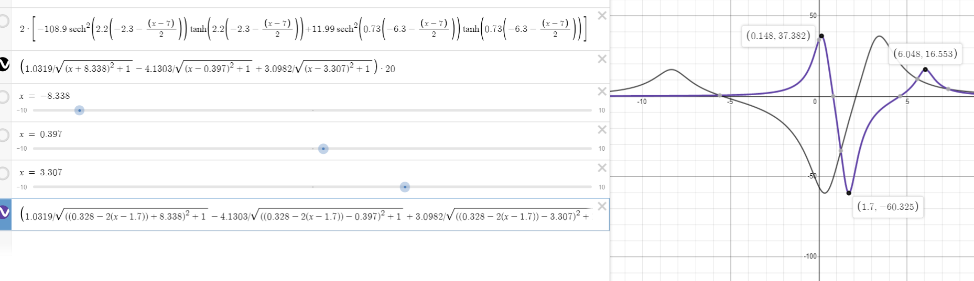

Now in general: Φe (x, t)= c * 10-9 * (1.0319 / sqrt(((x - 2(t - 1.7)) + 8.338)2 + 1) - 4.1303 / sqrt(((x - 2(t - 1.7)) - 0.397)2 + 1) + 3.0982 / sqrt(((x - 2(t - 1.7) - 3.307)2 + 1))



Juicy text for slides

Conclusions (still need to put in diff words, etc)

Many neurons have either a complex geometry, or large spatial extent, or both.

dendrites of [cerebellar](http://www.scholarpedia.org/article/Cerebellum) Purkinje cells, motor neurons that convey control signals from the central [nervous system](http://www.scholarpedia.org/article/Nervous_system) to distal muscles

The spatial extent of neurons provides both opportunity and difficulty.

a complex dendritic tree allows a neuron to receive a large number of synaptic inputs, the inputs can interact in highly nonlinear ways in the dendritic tree which goes well beyond just summing them up, thus allowing [dendritic computations](http://www.scholarpedia.org/w/index.php?title=Dendritic_processing&action=edit&redlink=1).

difficulty that, when they arrive at the soma, they will be filtered and attenuated.Current will be very different as seen by the soma

because of a neuron's cable properties, distal synapses and dendrites are *out of reach* of traditional electrophysiological studies using electrodes at the soma. One reason why we know so little about how neurons integrate their distal synaptic input is that it is extremely difficult to measure, or control, distal parts of the cell. Some progress along these lines has been made with modern optical methods (e.g. 2-photon microscopy) but even a complete descriptive characterization of a cell's behavior will not provide the thorough insights that results from a quantitative theory like cable theory.

Intro?

understand how electrical signals from different synapses are combined in the system of branching tubes of different diameters and membrane properties that forms the dendritic tree of a cell.

[Neuronal cable theory - Scholarpedia](http://www.scholarpedia.org/article/Neuronal_cable_theory)

Food for thought?

Linear cable theory lies at the core of our understanding of how an individual neuron works. Cable theory usually assumes that neurons do not interact significantly except at specific, anatomically specialized locations (synapses and gap junctions). An analysis of the extracellular electrical fields shows that spikes in one neuron could cause a depolarization of several mV in a dendrite or axon passing by its initial segment. Such interactions could possibly play a role in controlling action potential failure at branch points.

[A critical reexamination of some assumptions and implications of cable theory in neurobiology - CaltechTHESIS](http://thesis.library.caltech.edu/3499/)